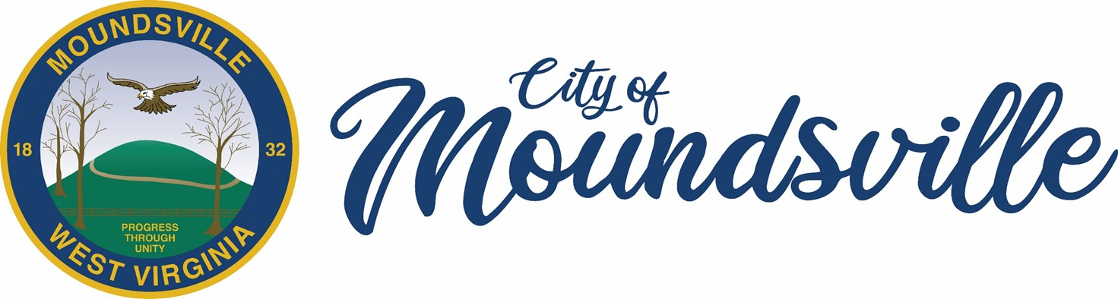
APPLICATION FOR THE
ON TRAC
EXTERIOR PAINT
GRANT PROGRAM
(JEFFERSON AVENUE FROM SECOND TO FIFTH STREET)

GRANTS UP TO $2,000.00
NO MATCH REQUIRED

Business Name ____________________________________________

Amount Requested _________________________
In 2024, the City of Moundsville was selected as one of three new “On Trac” communities through the West Virginia Office of Economic Development. On Trac is a downtown revitalization program and community development model that focuses on enhancing and supporting the unique character of the downtown business district. We are pleased to announce the Moundsville On Trac Business Exterior Paint Grant Program. This grant is designed to assist businesses in upgrading their building exterior with a fresh coat of paint in a color selected from the approved historical paint palette, Sherwin-Williams Craftsman Style Exterior Paint.
https://www.sherwin-williams.com/en-us/color/color-collections/architectural-paint-colors/craftsman-design-exterior-paint-colors

The grant will cover paint and labor costs up to $2,000.

All businesses that apply and are deemed qualified will receive a one-time financial grant of up to a maximum of $2,000.00 to assist with exterior painting. We encourage all eligible businesses to apply for this exciting opportunity to improve their businesses and contribute to the growth and vibrancy of Jefferson Avenue. Please refer to the official grant guidelines for detailed information about the application process, eligibility, and funding limits.

Any questions regarding eligibility or project can be directed to the City Manager's Office at 304-845-6300. When the application is completed, return it to the City Manager’s Office, addressed to Moundsville On Trac Paint Program, City of Moundsville, 800 6th Street, Moundsville, WV 26041. Applications will be accepted until allocated program funds are exhausted. The application will be reviewed by Moundsville On Trac and then forwarded for final approval by the City Manager.

PROCESS
Upon receipt of the application, an approval process will begin. The City Clerk’s Office will review the application and ensure it is complete and correct. The application will then be forwarded to the Building Inspection Department (if the project requires this approval). Finally, the City Manager will approve or deny the application, based on all of the information discovered during the review. All applicants will receive written notice of the decision. Receipts of purchase, quotes, and documentation will be required.

ELIGIBILITY
- Eligible Applicants: Eligible applicants include owners or renters of commercial properties and owners or renters of businesses located in the On Trac district. All applicants (based on owner, address, and/or tenant) must be current on all city-related bills including water, sewer, stormwater, garbage, municipal fee, public safety fee, Business & Occupation taxes, and must have a current City License. The Committee reserves the right to deny funding to applicants who are delinquent on any fees or have any judgements, liens, or delinquent payment arrangements.
- Eligible Areas: The eligible area is defined as the On Trac district (further defined as Jefferson Avenue between Second Street and Fifth Street, including the Strand Theatre).
- Eligible Expenditures: For purposes of this program, eligible improvements include painting and labor only. No reimbursement will be made for any expenditure deemed ineligible during the approval process. Improvements must be consistent with recommendations set forth in any applicable master plans for the area in which the property is located.

GENERAL RULES
All work must be completed by licensed contractors (if applicable), legally operating in the City of Moundsville. The applicant is responsible for obtaining necessary building/site permits for all work. Applicants should contact the City’s Building Inspection Department for assistance with permits, and contractor licensing. All contractors are responsible for paying any project related Business & Occupation Tax. Any work to be done by the owner would be handled on a case-by-case basis but would require quotes from material suppliers with the application.

In no event shall the City be obligated to provide any assistance awards that would exceed the allocated amount for this purpose.

Any physical work commenced or completed by any program participants prior to the issuance of a “Notice to Proceed” by the City Manager is ineligible for any award(s) pursuant to the program.

Additional Grant Guidelines

- The entire application must be completed. Application will be returned if there are any blanks or unanswered questions.
- Estimates must be included with documentation.
- Business must be current on all city accounts, including:
  - Garbage
  - Municipal Fee
  - Public Safety Fee
  - Water/Sanitary/Stormwater
  - Business & Occupation Tax
  - City License
  - Citations
  - Judgements
  - Payment Arrangements
- Owner must secure a Building Permit and follow all applicable codes, if project requires.
- Work shall be done by a contractor (if applicable) who must have state and city contractor licenses and be current on all Business & Occupation Taxes. If the owner completes the work, there will be no payment for labor.
- Building Inspectors will complete a final inspection when work is finished. Total project receipts must be turned in to the City Manager’s Office showing expenditure of grant funding, within seven days following completion of work. Once completed, reimbursement will be made.

PLEASE START THE APPLICATION ON THE NEXT PAGE
APPLICATION SECTION

BUSINESS NAME
PHYSICAL BUSINESS LOCATION ADDRESS
MAILING ADDRESS
PROPERTY OWNER’S NAME
MAILING ADDRESS
PHONE NUMBER
E-MAIL ADDRESS
TYPE OF TENANCY | OWN RENT LEASE
LENGTH OF TIME AT THIS LOCATION
LENGTH OF LEASE TERM
(IF APPLICABLE)
OCCUPANCY OF STREET LEVEL FLOOR | FULL VACANT

ARE YOU CURRENT ON THE FOLLOWING CITY BILLS?
WATER AND SEWAGE | YES NO
STORMWATER, | YES NO
GARBAGE | YES NO
PUBLIC SAFETY FEE | YES NO
MUNICIPAL FEE | YES NO
BUSINESS & OCCUPATION TAX | YES NO
BUSINESS LICENSE | YES NO
DO YOU HAVE ANY OUSTANDING UNPAID PAYMENT ARRANGEMENTS, CITATIONS OR JUDGEMENTS?  (If no, all accounts must be current to apply.) | YES NO

1. What exterior spaces will be painted? Please describe the project in detail.
(Attach additional sheets if necessary.)
____________________________________________________________________________

____________________________________________________________________________

____________________________________________________________________________

____________________________________________________________________________

____________________________________________________________________________

____________________________________________________________________________

____________________________________________________________________________

2. Please provide a cost estimate.
(Example: paint, estimate from a Contractor for labor, etc.)
____________________________________________________________________________

____________________________________________________________________________

____________________________________________________________________________

____________________________________________________________________________

____________________________________________________________________________

____________________________________________________________________________

____________________________________________________________________________

3. Who will be doing the work? _______________________________________________

4. Estimated Start and Completion Date? _______________________________________

I acknowledge that the City of Moundsville, WV is obligated only to administer the grant procedures and is not liable to the applicant, owner or their parties for any obligations or claims of any nature growing out, or arising out of, the application or project undertaken by the applicant and/or owner.
- I acknowledge that all of the information I provided in this application is true, to the best of my knowledge.
- I acknowledge that I will use grant funds for allowable reasons and will provide documentation of expenditures.
- I agree to have this project complete, inspected, and receipts turned into the City Clerk’s Office within 90 days of award. Any need for a longer time will be addressed on a case-by-case basis.

Signatures:

______________________________________________________________________________
Applicant Date

______________________________________________________________________________
Co-Applicant Date

OFFICE USE ONLY
Task | Signature | Date
Date Application Received
Review Process
- Is Garbage Bill Current?
- Is Municipal Fee Current?
- Is Public Safety Fee Current?
- Is Water/Sanitary/Stormwater Current?
- Are there any Unpaid Citations?
- Are there any Unpaid Judgements/Liens?
- Is Business & Occupation Tax Current?
- Is City Business License Current?
- Are Any Payment Arrangements Current?
Historic Landmarks Review and Comments.
Building Inspectors Approval to Move Forward
City Manager’s Approval
Amount of Grant Approved
Grant Expended, Include Check #

Comments:
____________________________________________________________________________

____________________________________________________________________________

____________________________________________________________________________

____________________________________________________________________________

____________________________________________________________________________

____________________________________________________________________________

