CONSUMER CONFIDENCE REPORT
for the calendar year 2024

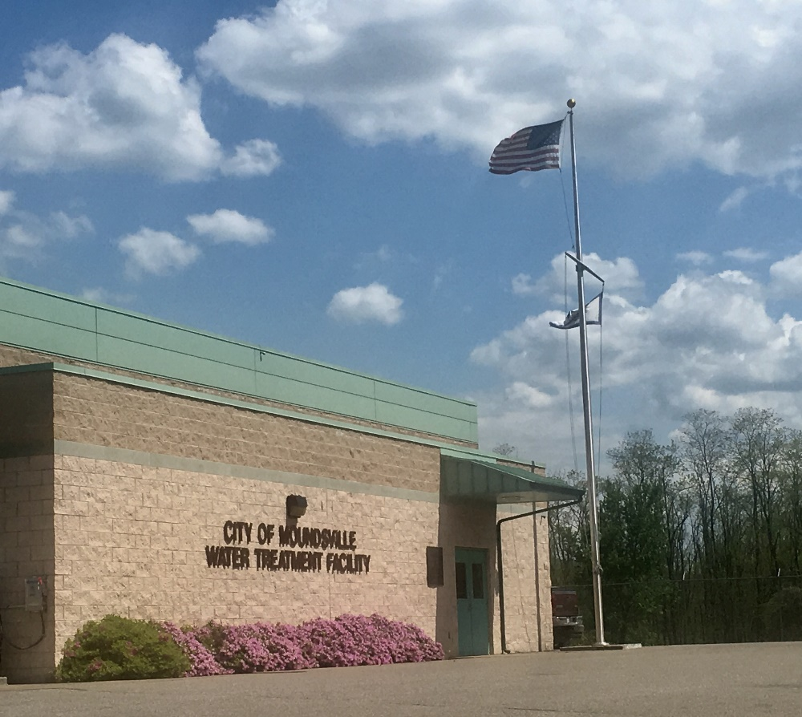
Water Treatment Plant - Front View along Ohio River

Dedicated To Quality Drinking Water

Water Quality Report Created June 1, 2025

Moundsville Water Board
PO Box 480, 800 Sixth Street
Moundsville, WV 26041
Phone - (304) 845-0380
P.W.S. #WV 3302611


MOUNDSVILLE WATER BOARD - WV3302611
Consumer Confidence Report – 2025
Covering Calendar Year – 2024

This brochure is a snapshot of the quality of the water that we provided last year. Included are the details about where your water comes from, what it contains, and how it compares to Environmental Protection Agency (EPA) and state standards.
We are committed to providing you with this information because informed customers are our best allies.

Your water comes from Ground water:

Source Name | Source Water Type
WELL #8A | Ground water
WELL #9 | Ground water
WELL #10 | Ground water
WELL #11 | Ground water
WELL #12 | Ground water
WELL #12A | Ground water
WELL #13 | Ground water
WELL #14 | Ground water
WELL #15 | Ground water
WELL #16 | Ground water

Some people may be more vulnerable to contaminants in drinking water than the general population. Immuno-compromised persons such as those with cancer undergoing chemotherapy, persons who have undergone organ transplants, people with HIV/AIDS or other immune system disorders, some elderly, and infants can be particularly at risk from infections. These people should seek advice about drinking water from their health care providers. EPA/CDC guidelines on appropriate means to lessen the risk of infection by Cryptosporidium and other microbial contaminants are available from the Safe Drinking Water Hotline (800-426-4791).

Drinking water, including bottled water, may reasonably be expected to contain at least small amounts of some contaminants. The presence of contaminants does not necessarily indicate that water poses a health risk. More information about contaminants and potential health effects can be obtained by calling the EPA’s Safe Drinking Water Hotline (800-426-4791).

The sources of drinking water (both tap water and bottled water) included rivers, lakes, streams, ponds, reservoirs, springs, and wells. As water travels over the surface of the land or through the ground, it dissolves naturally occurring minerals and, in some cases, radioactive material, and can pick up substances resulting from the presence of animals or from human activity.

Contaminants that may be present in sources water before we treat it include:

Microbial contaminants, such as viruses and bacteria, which may come from sewage treatment plants, septic systems, livestock operations and wildlife.
Inorganic contaminants, such as salts and metals, which can be naturally occurring or result from urban storm water runoff, industrial or domestic wastewater discharges, oil and gas production, mining or farming.
Pesticides and herbicides, which may come from a variety of sources such as storm water run-off, agriculture, and residential users.
Radioactive contaminants, which can be naturally occurring or the result of mining activity.
Organic contaminants, including synthetic and volatile organic chemicals, which are by-products of industrial processes and petroleum production, and also come from gas stations, urban storm water run-off, and septic systems.

In order to ensure that tap water is safe to drink, EPA prescribes regulation which limits the amount of certain contaminants in water provided by public water systems. We treat our water according to EPA’s regulations.
Food and Drug Administration (FDA) regulations establish limits for contaminants in bottled water, which must provide the same protection for public health.

Terms & Abbreviations

Maximum Contaminant Level Goal (MCLG): the “Goal” is the level of a contaminant in drinking water below which there is no known or expected risk to human health. MCLGs allow for a margin of safety.
Maximum Contaminant Level (MCL): the “Maximum Allowed” is the highest level of a contaminant that is allowed in drinking water. MCLs are set as close to the MCLGs as feasible using the best available treatment technology.
Secondary Maximum Contaminant Level (SMCL): recommended level for a contaminant that is not regulated and has no MCL.
Action Level (AL): the concentration of a contaminant that, if exceeded, triggers treatment or other requirements.
Treatment Technique (TT): a required process intended to reduce levels of a contaminant in drinking water.
Maximum Residual Disinfectant Level (MRDL): the highest level of a disinfectant allowed in drinking water. There is convincing evidence that addition of a disinfectant is necessary for control of microbial contaminants.
Non-Detects (ND): lab analysis indicates that the contaminant is not present.
Parts per Million (ppm): or milligrams per liter (mg/L). This is equivalent to 1 drop of water in a 10 gallon fish tank.
Parts per Billion (ppb): or micrograms per liter (µg/L). This is equivalent to 1 drop of water in a 10,000 gallon swimming pool.
Parts per Trillion (ppt): or nanograms per liter (ng/L). This is equivalent to 1 drop of water in 35 junior size Olympic swimming pools.
Picocuries per Liter (pCi/L): a measure of the radioactivity in water.
Millirems per Year (mrem/yr): measure of radiation absorbed by the body.
Monitoring Period Average (MPA): An average of sample results obtained during a defined time frame, common examples of monitoring periods are monthly, quarterly and yearly.
Nephelometric Turbidity Unit (NTU): a measure of the clarity of water. Turbidity in excess of 5 NTU is just noticeable to the average person. Turbidity is not regulated for groundwater systems.
Running Annual Average (RAA): an average of sample results obtained over the most current 12 months and used to determine compliance with MCLs.
Locational Running Annual Average (LRAA): Average of sample analytical results for samples taken at a particular monitoring location during the previous four calendar quarters.

If you would like to observe the decision-making process that affects drinking water quality or if you have questions, comments, or suggestions, please attend any regular scheduled Water Board meeting held on the 2nd and 4th Mondays of each month at 5:00pm in the Moundsville City Council Chambers, 800 Sixth Street or call Superintendent Terry Roberts at 304-845-3028.

AVAILABILITY OF MONITORING DATA FOR UNREGULATED CONTAMINANTS
In 2023, our water system sampled for a series of unregulated contaminants (UCMR5). Unregulated contaminants are those that do not yet have a drinking water standard set by the US Environmental Protection Agency (EPA). The purpose of monitoring for these contaminants is to help EPA decide whether the contaminants should have a standard. As our customers, you have a right to know that this data is available.
If you are interested in examining the results, please contact:
The Moundsville Water Board at 304-845-3028.

Testing Results for: MOUNDSVILLE
Water Quality Data

The following tables list all of the drinking water contaminants which were detected during the 2024 calendar year. The presence
of these contaminants does not necessarily indicate the water poses a health risk. Unless noted, the data presented in this table
is from the testing done January 1 - December 31, 2024. The state requires us to monitor for certain contaminants less than once
per year because the concentrations of these contaminants are not expected to vary significantly from year to year. Some of the
data, though representative of the water quality, is more than one year old.

Disinfection Byproducts | Sample Point | Collection Date | Compliance Achieved | Highest LRAA Value | Range  (low/high) | Unit | MCL | MCLG | Typical Source
TTHM | MOUNDSVILLE WASTE WATER TP | 2024 | Yes | 4 | 4 - 4 | ppb | 80 | 0 | By-product of drinking water chlorination
TTHM | E.FOURTH STREET | 2024 | Yes | 5 | 5 - 5 | ppb | 80 | 0 | By-product of drinking water chlorination
TOTAL HALOACETIC ACIDS (HAA5) | MOUNDSVILLE WASTE WATER TP | 2024 | Yes | <0.001 | 0 - 0 | ppb | 60 | 0 | By-product of drinking water disinfection
TOTAL HALOACETIC ACIDS (HAA5) | E.FOURTH STREET | 2024 | Yes | <0.001 | 0 - 0 | ppb | 60 | 0 | By-product of drinking water disinfection
Regulated Contaminants | Collection Date | Compliance Achieved | Highest Value | Range | Unit | MCL | MCLG | Typical Source
BROMATE | 6/6/2024 | Yes | <0.001 | <0.001 | ppm | 10 | 0 | By-product of drinking water chlorination
BROMIDE | 1/18/2024 | Yes | 1.5 | 1.5 | ppm | 5 | 5 | By-product of drinking water chlorination
BARIUM | 8/4/2022 | Yes | 0.0133 | 0.0133 | ppm | 2 | 2 | Discharge of drilling wastes; Discharge from metal refineries; Erosion of natural deposits.
FLUORIDE | 4/25/2024 | Yes | 0.65 | 0.65 | ppm | 4 | 4 | Erosion of natural deposits; Water additive which promotes strong teeth; Discharge from fertilizer and aluminum factories
NITRATE | 8/8/2024 | Yes | 0.49 | 0.49 | ppm | 10 | 10 | Runoff from fertilizer use; Leaching from septic tanks, sewage; Erosion of natural deposits
NITRITE | 8/8/2024 | Yes | <0.070 | <0.070 | ppm | 50 | 0 | Runoff from fertilizer use; Leaching from septic tanks, sewage; Erosion of natural deposits
NITRATE-NITRITE | 8/8/2024 | Yes | 0.49 | 0.49 | ppm | 10 | 10 | Runoff from fertilizer use; Leaching from septic tanks, sewage; Erosion of natural deposits
TRICHLOROETHENE (TCE) | 8/8/2024 | Yes | <0.001 | <0.001 | ppm | 5 | 50 | Discharge from metal degreasing sites and other factories

Chlorine/Chloramines - Maximum Disinfection Level | MPA | MPA Units | RAA | RAA Units
12/1/2024 - 12/31/2024 | 0.60000 | MG/L | 0.60000 | MG/L
Radiological Contaminants | Collection Date | Highest Value | Range | Unit | MCL | MCLG | Typical Source
GROSS ALPHA, EXCL. RADON & U | 8/4/2022 | 2.34 | NA | pCi/L | 15 | 0 | Erosion of natural deposits
RADIUM-228 | 8/4/2022 | 0.472 | 0.472 | pCi/L | 0 | 0 | Erosion of natural deposits

Secondary Contaminants-Non Health Based Contaminants-No Federal Maximum Contaminant Level (MCL) Established. | Collection Date | Highest Value | Range  (low/high) | Unit | SMCL
SODIUM | 8/4/2022 | 14.5 | NA | MG/L | 1000

TOTAL COLIFORM RULE
Substance | Monitoring Period | Compliance Achieved | MCLG | MCL | Highest Percentage | Typical Source
TOTAL COLIFORM | 2024 | Yes | NA | A | 0% | Naturally present in the environment
E.COLI | 2024 | Yes | 0 | A | 0% | Human and animal fecal waste

Our water system has an estimated population of 9911 and is required to test a minimum of 10 sample(s) per month in accordance with the Total Coliform Rule for microbiological contaminants. Coliforms are bacteria that are naturally present in the environment and are used as an indicator that other, potentially harmful waterborne pathogens may be present, or that a potential pathway exists through which contamination may enter the drinking water distribution system. If we found coliforms, it can indicate the need to look for potential problems in water treatment or distribution. Should this occur, we are required to conduct assessment(s) to identify and correct any problems that were found during these assessments.

The results of our monthly testing in 2024 shows an (A) absence of coliform and E.coli in our water samples.

Unresolved Deficiency  Date Identified | Facility | Comments
5/18/2021 | WATER SYSTEM | Physical implementation of the cross connection and back flow prevention program has not been addressed. Water unaccountability has seen minor yet positive improvements and will be reduced to a minor deficiency in this report. Please note that these two topics were listed as deficiencies in 2011, 2016 and are listed in this 2021 report
To address this Deficiency, Moundsville Water Board instituted an active Backflow/Cross Connection Prevention Program working in conjunction with AquaBackflow. The Backflow/Cross Connection Prevention Program began March 2023.

During the 2024 calendar year, we had the below noted violation(s) of drinking water regulations:
NONE
There are no additional required health effects violation notices.

There are no additional required health effects notices.

Lead & Copper Sampling and Lead Service Line Inventory

Lead and Copper | Monitoring Period | 90TH Percentile | Range  (low/high) | Unit | AL | Sites  Over AL | Typical Source
COPPER, FREE | 2020 - 2022 | 0.235 | 0.0054 - 0.272 | ppm | 1.3 | 0 | Corrosion of household plumbing systems; Erosion of natural deposits; Leaching from wood preservatives
LEAD | 2020 - 2022 | 0.00082 | 0.000076 – 0.0052 | ppm | 15 | 0 | Corrosion of household plumbing systems; Erosion of natural deposits
Moundsville Water Board completed lead and copper tap sampling in 2020 – 2022, the results of which are available for review and can be accessed by contacting the Moundsville Water Board at 304-845-3028.
Lead and copper tap sampling will be conducted again in August 2025.
There is no safe level of lead in drinking water. Exposure to lead in drinking water can cause serious health effects in all age groups, especially pregnant people, infants (both formula-fed and breastfed), and young children. Some of the health effects to infants and children include decreases in IQ and attention span. Lead exposure can also result in new or worsened learning and behavior problems. The children of persons who are exposed to lead before or during pregnancy may be at increased risk of these harmful health effects. Adults have increased risks of heart disease, high blood pressure, kidney or nervous system problems. Contact your health care provider for more information about your risks.
Lead can cause serious health effects in people of all ages, especially pregnant people, infants (both formula-fed and breastfed), and young children. Lead in drinking water is primarily from materials and parts used in service lines and in home plumbing. MOUNDSVILLE is responsible for providing high quality drinking water and removing lead service pipes but cannot control the variety of materials used in the plumbing in your home. Because lead levels may vary over time, lead exposure is possible even when your tap sampling results do not detect lead at one point in time. You can help protect yourself and your family by identifying and removing lead materials within your home plumbing and taking steps to reduce your family's risk.

Using a filter, certified by an American National Standards Institute accredited certifier to reduce lead, is effective in reducing lead exposures. Follow the instructions provided with the filter to ensure the filter is used properly. Use only cold water for drinking, cooking, and making baby formula. Boiling water does not remove lead from water. Before using tap water for drinking, cooking, or making baby formula, flush your pipes for several minutes. You can do this by running your tap, taking a shower, doing laundry or a load of dishes. If you have a lead service line or galvanized requiring replacement service line, you may need to flush your pipes for a longer period. If you are concerned about lead in your water and wish to have your water tested, contact Moundsville Water Board at 304-845-3028. Information on lead in drinking water, testing methods, and steps you can take to minimize exposure is available at https://www.epa.gov/safewater/lead.

Infants and children are typically more vulnerable to lead in drinking water than the general population. It is possible that lead levels at your home may be higher than at other homes in the community as a result of materials used in your home's plumbing . If you are concerned about elevated lead levels in your home's water, you may wish to have your water tested and flush your tap for 30 seconds to 2 minutes before using tap water. Additional information is available from the Safe Drinking Water Hotline ( 800-426-4791) or at
http://www.epa.gov/safewater/lead.

MOUNDSVILLE WATER BOARD is preparing a service line inventory identifying the service line materials throughout the water distribution supply. You may be contacted by the Moundsville Water Board for information about the internal water supply lines of your residence.

The most up to date inventory is located at the Moundsville Water Treatment Plant. By November 1, 2027, our water system must develop an updated initial inventory, known as the “baseline inventory” and it must include each service line and identified connector that is connected to the public water distribution system. Our water system identified lead status unknown service lines in our inventory. Due to this identification our water system must create a service line replacement plan by November 1, 2027.

If you have any questions about our inventory or if you would like information about our service line replacement plan, please contact the Moundsville Water Board at 304-845-3028.

Your CCR is available at https://www.cityofmoundsville.com/departments/water-department/31 or at https://www.cityofmoundsville.com/docs/ln_2023WaterQualityReport.pdf.

To receive a paper copy in the mail - please contact the Moundsville Water Board by phone at
304-845-0380 or by mail at PO Box 480, Moundsville, WV 26041.

To receive a copy in person – a copy can be picked up at the Moundsville Water Board Billing Office located in the Moundsville City Building, 800 Sixth Street, Moundsville, WV 26041.

